Since 1930, what do you think has happened to the percent of Americans who say it is “essential” to live in a democracy?
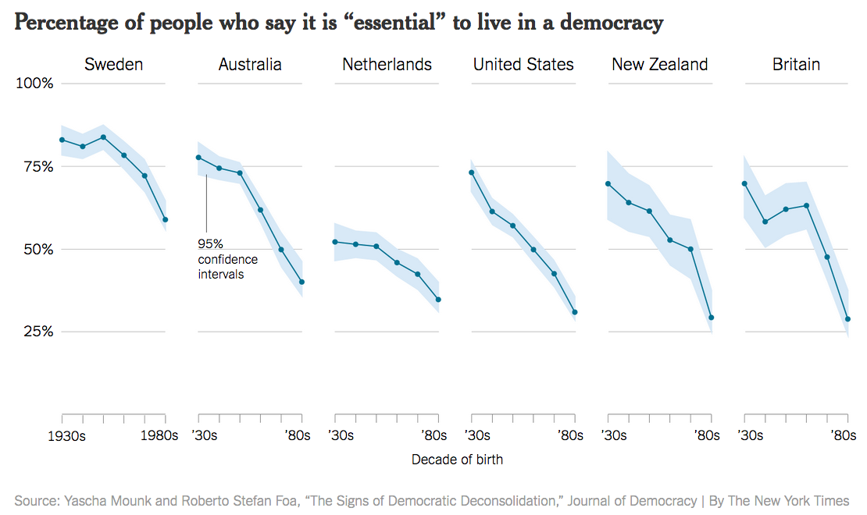

How accurate was your prediction?

What most surprised you about this data?

Is this good news or bad news?

What is the big trend you see in this data?

What are two causes of this trend?

What are two consequences of this trend?

Explain whether you believe that it is "essential" to live in a democracy?

How does the U.S. compare to the other countries in this chart?

Based on the trends in this data, how much longer do you think democracy will last in the U.S.?

What questions do you have about this information?

Explain how this data connects to this year's presidential elections?

Learning Extension

Read the entire scary article about the de-democratization of the world.

Action Extension

Create a poll on facebook, Twitter, or Poll Everywhere to survey ten of your friends about the following question: Do you believe that it is "essential" to live in a democracy? Share the results online and in class.

